**Application Gateway (Load Balancer)**

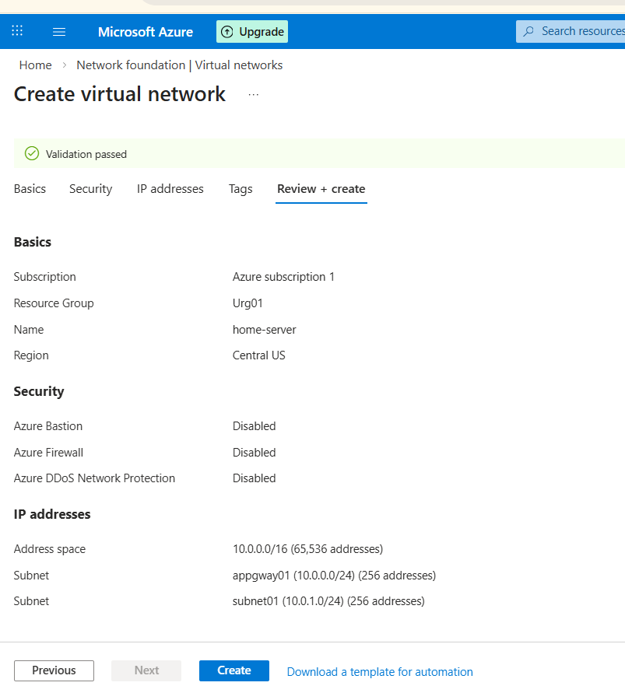

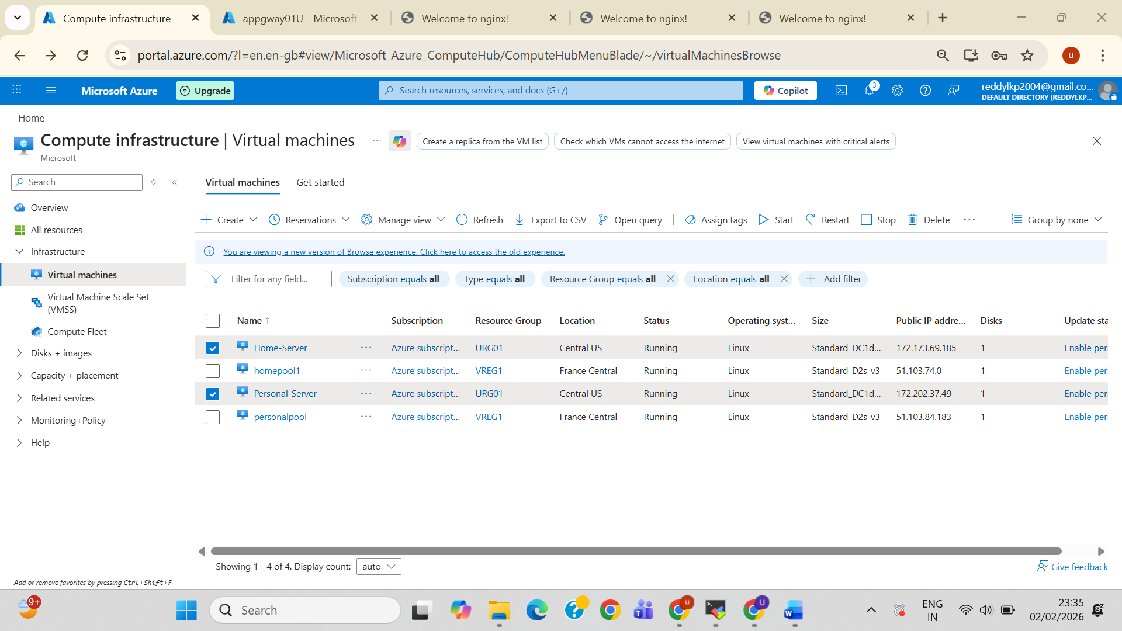

* Browse both servers on browser using Public-ip
* You will see below result of both servers

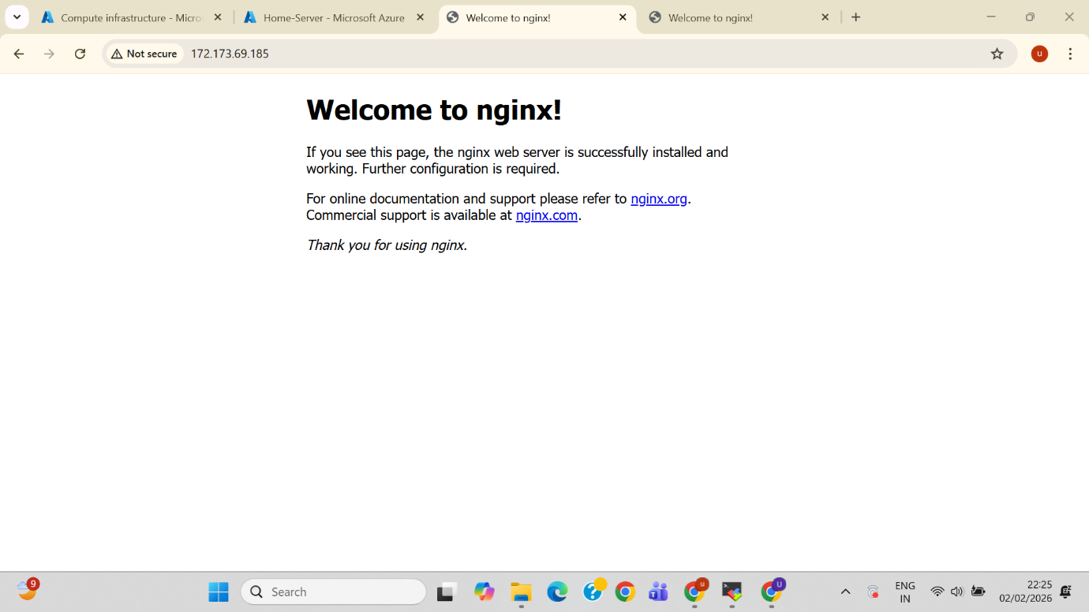

* Next Login to **personal-server** and create **personal folder** and move **index.** file to **personal directory.**
* Edit Content inside index. file and save it.

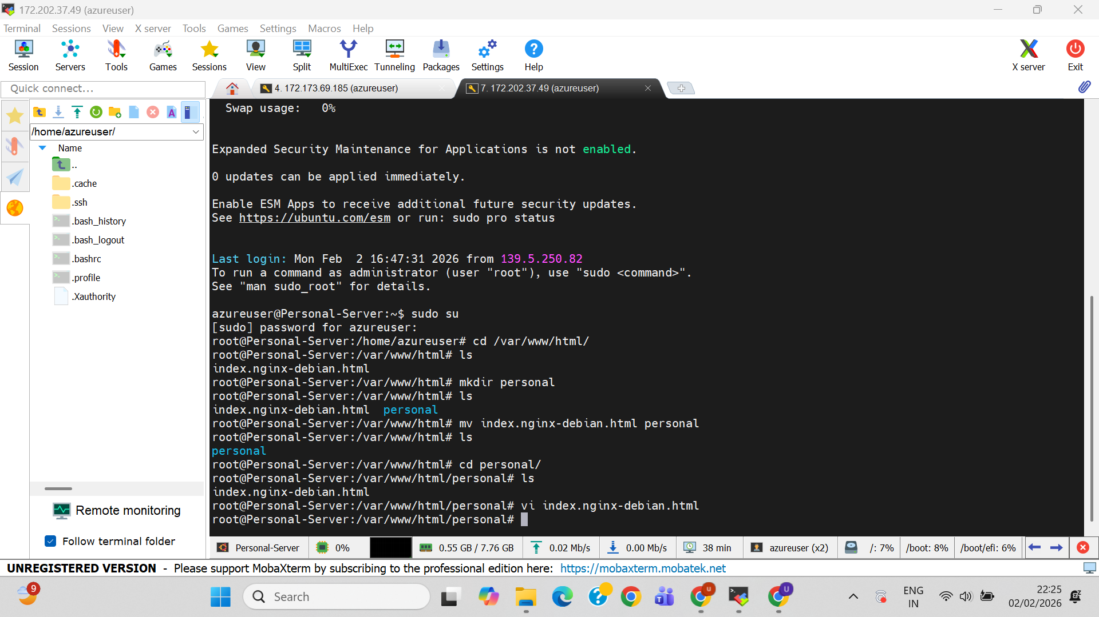

* We see **edit content** on **browser** and we can access by using **PublicIp/personal/**

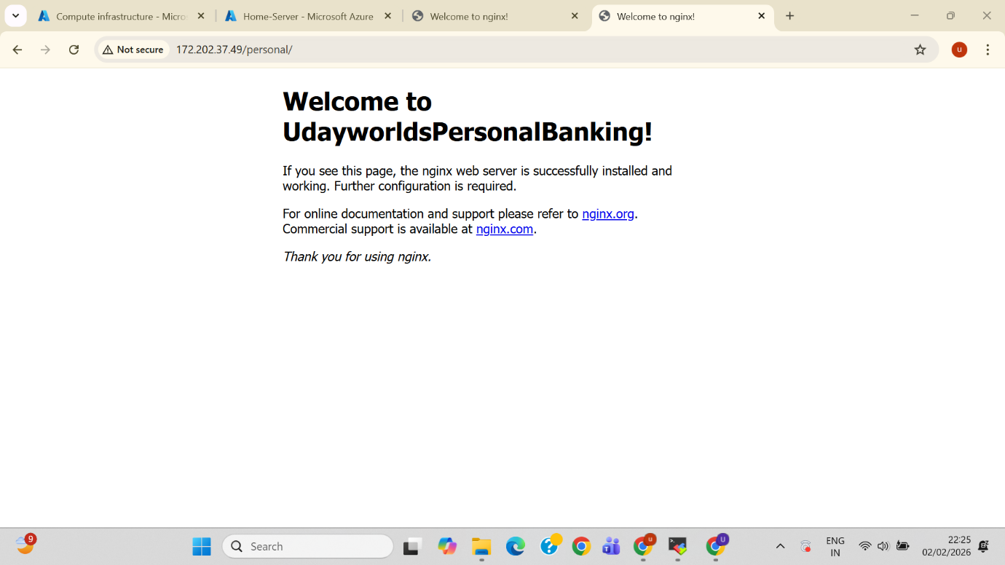

* Know let’s create **Application Gatew**

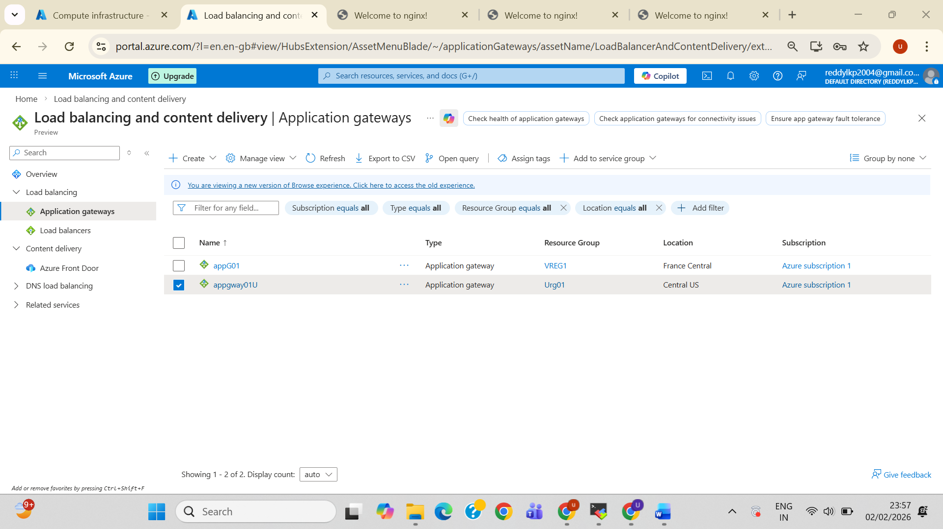

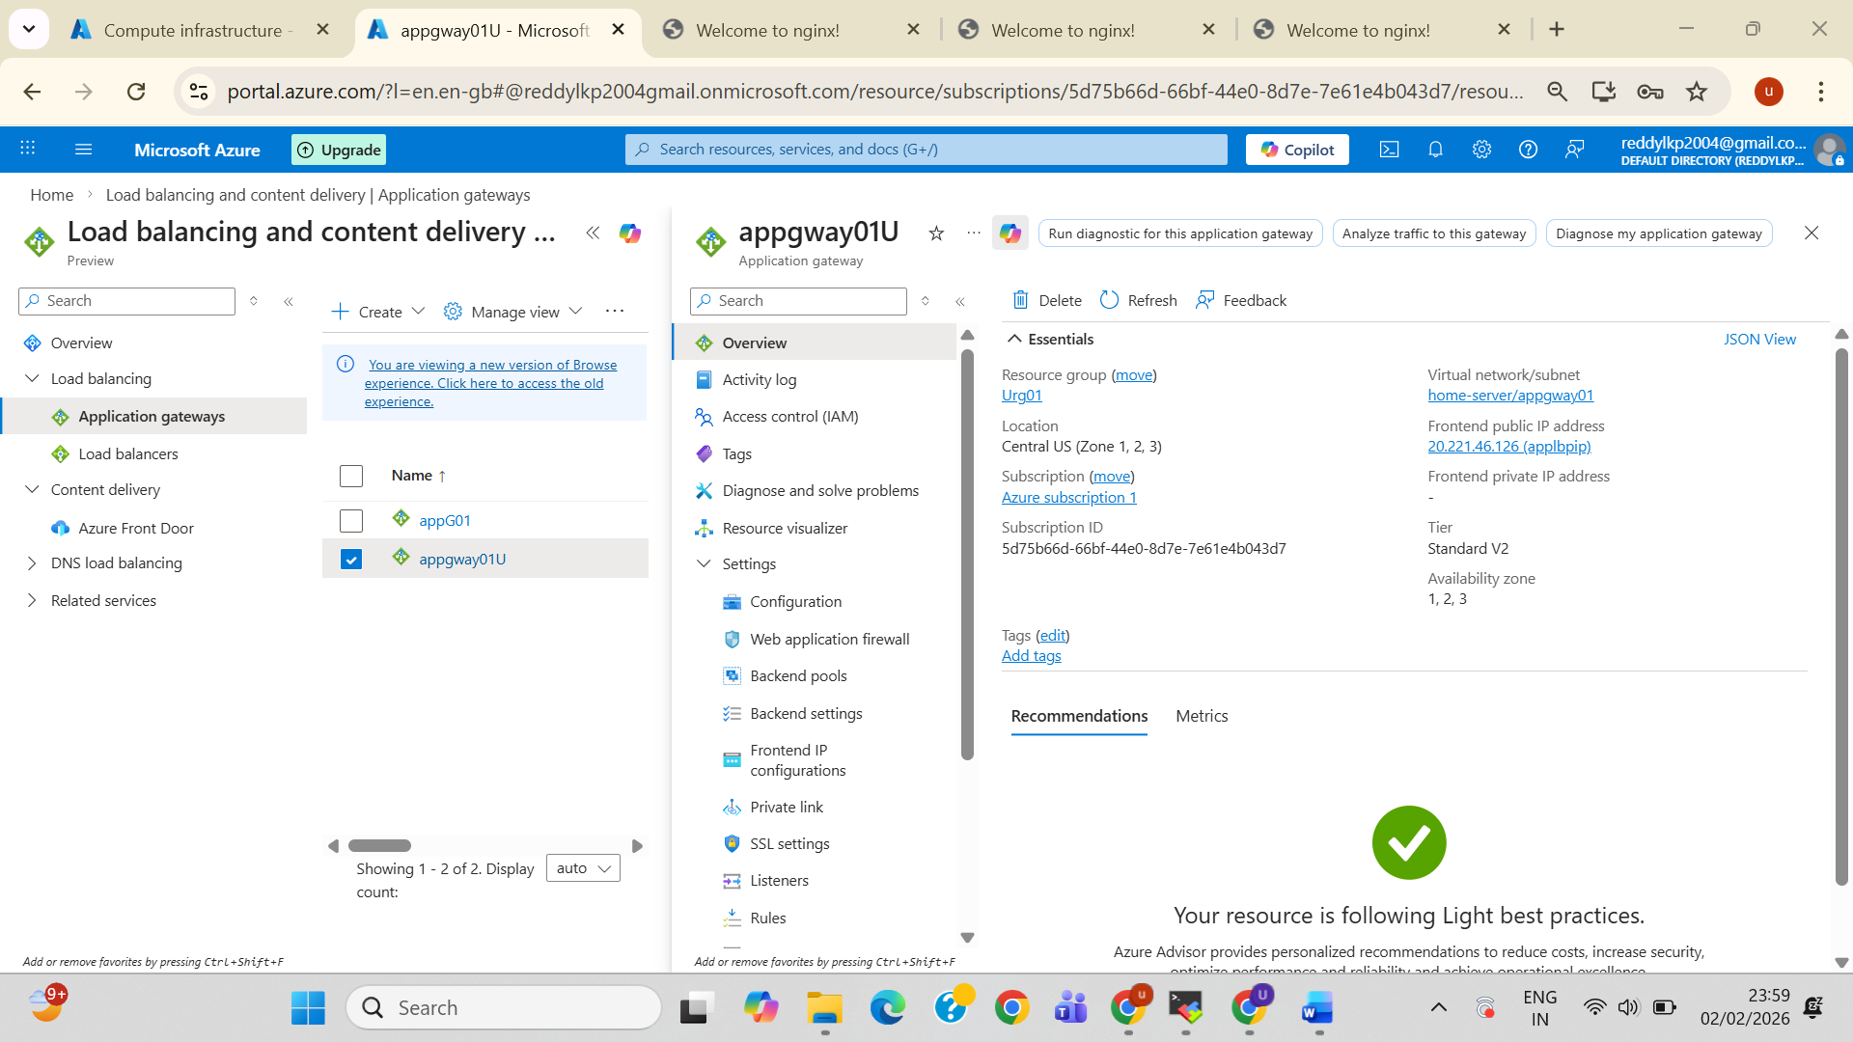

* **Backend pools(Home & personal)**

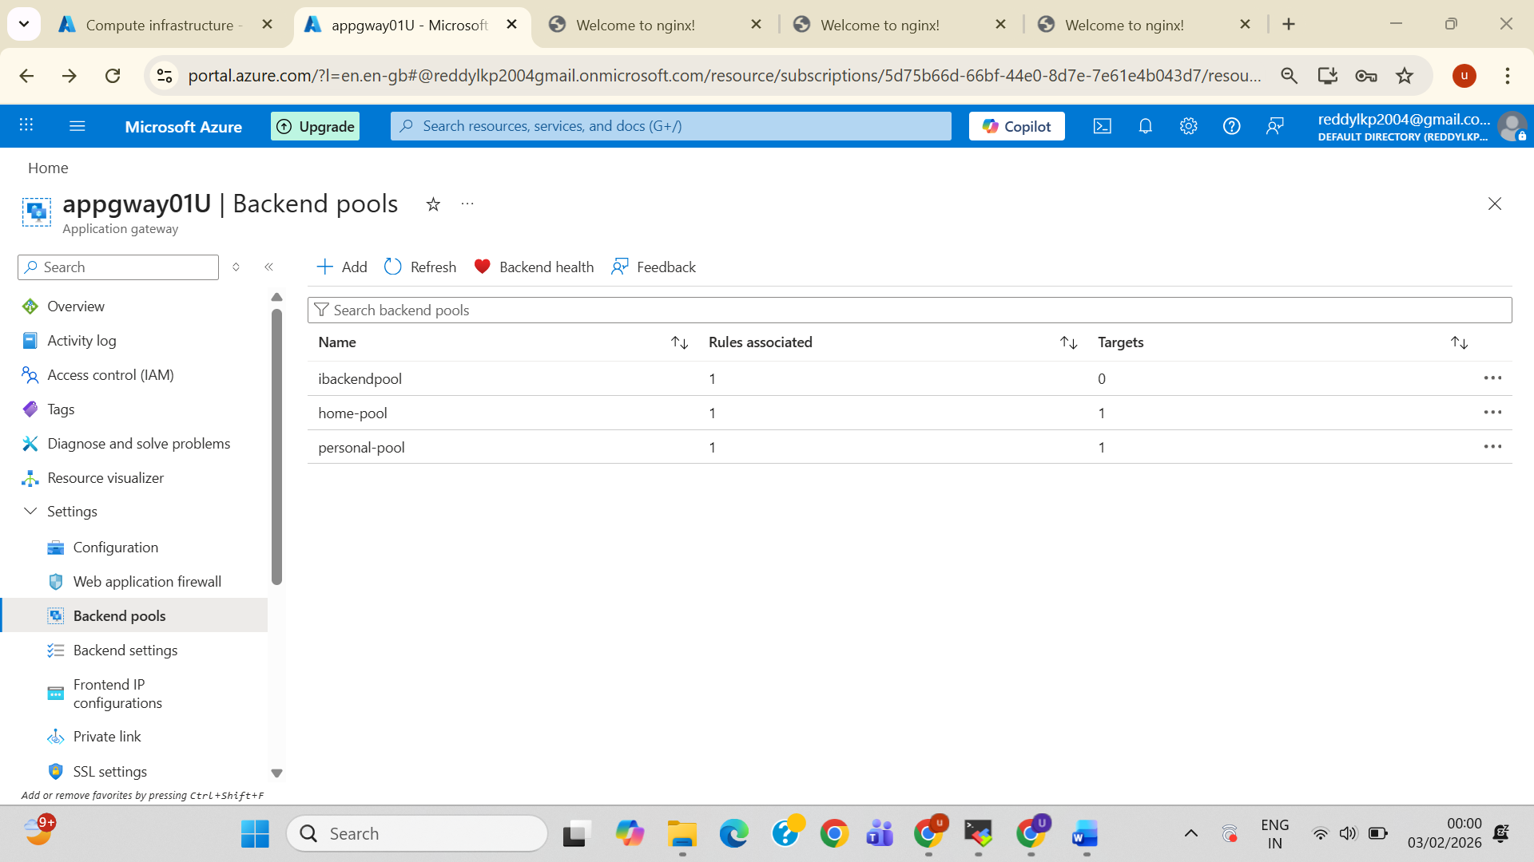

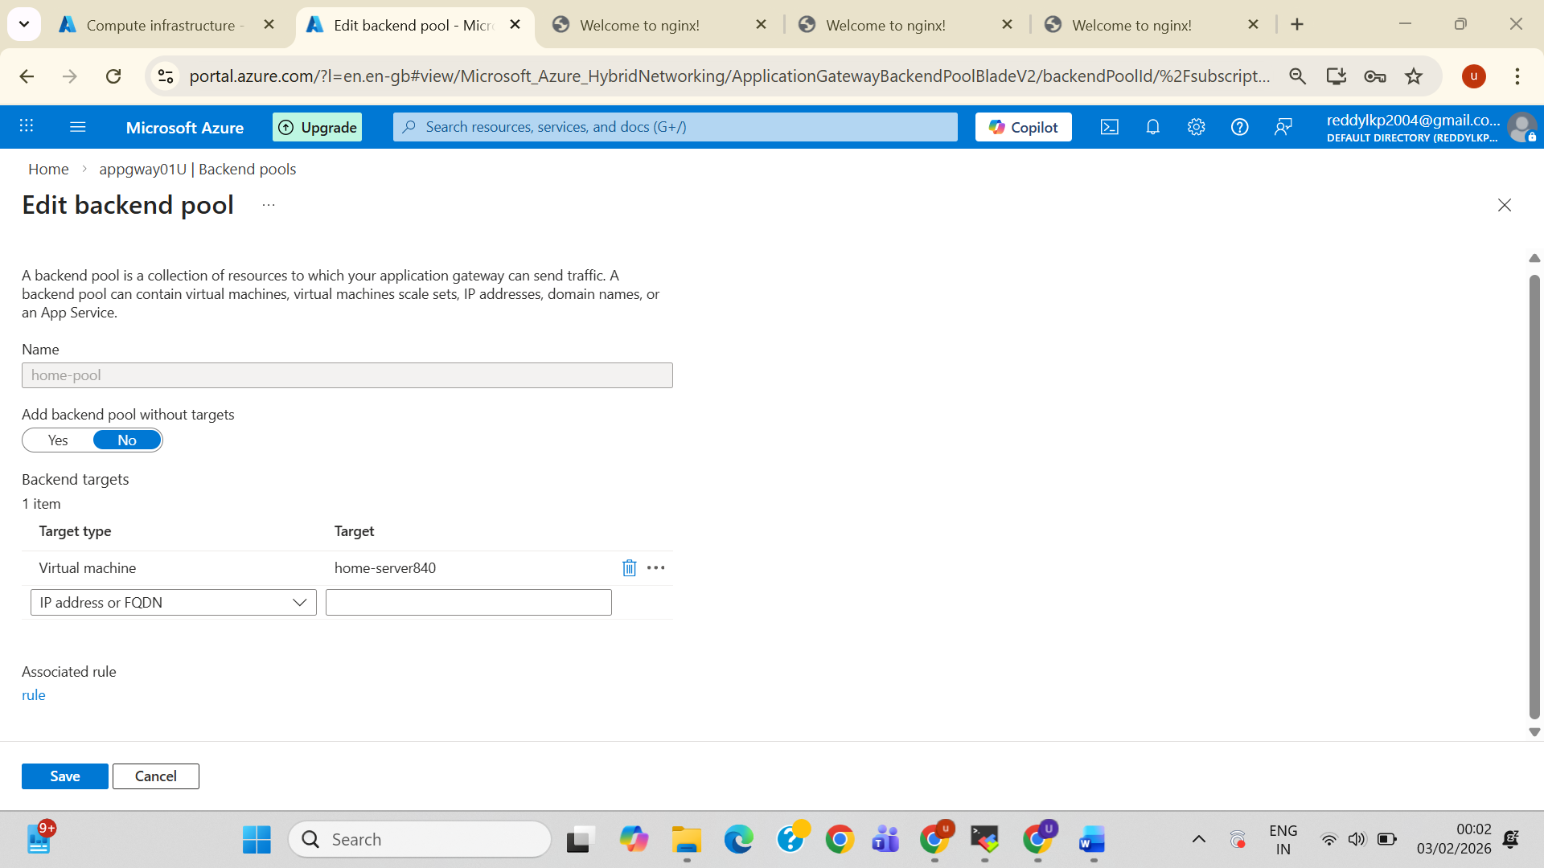

* **Backend settings(homeSettings & PersonalSettings)**

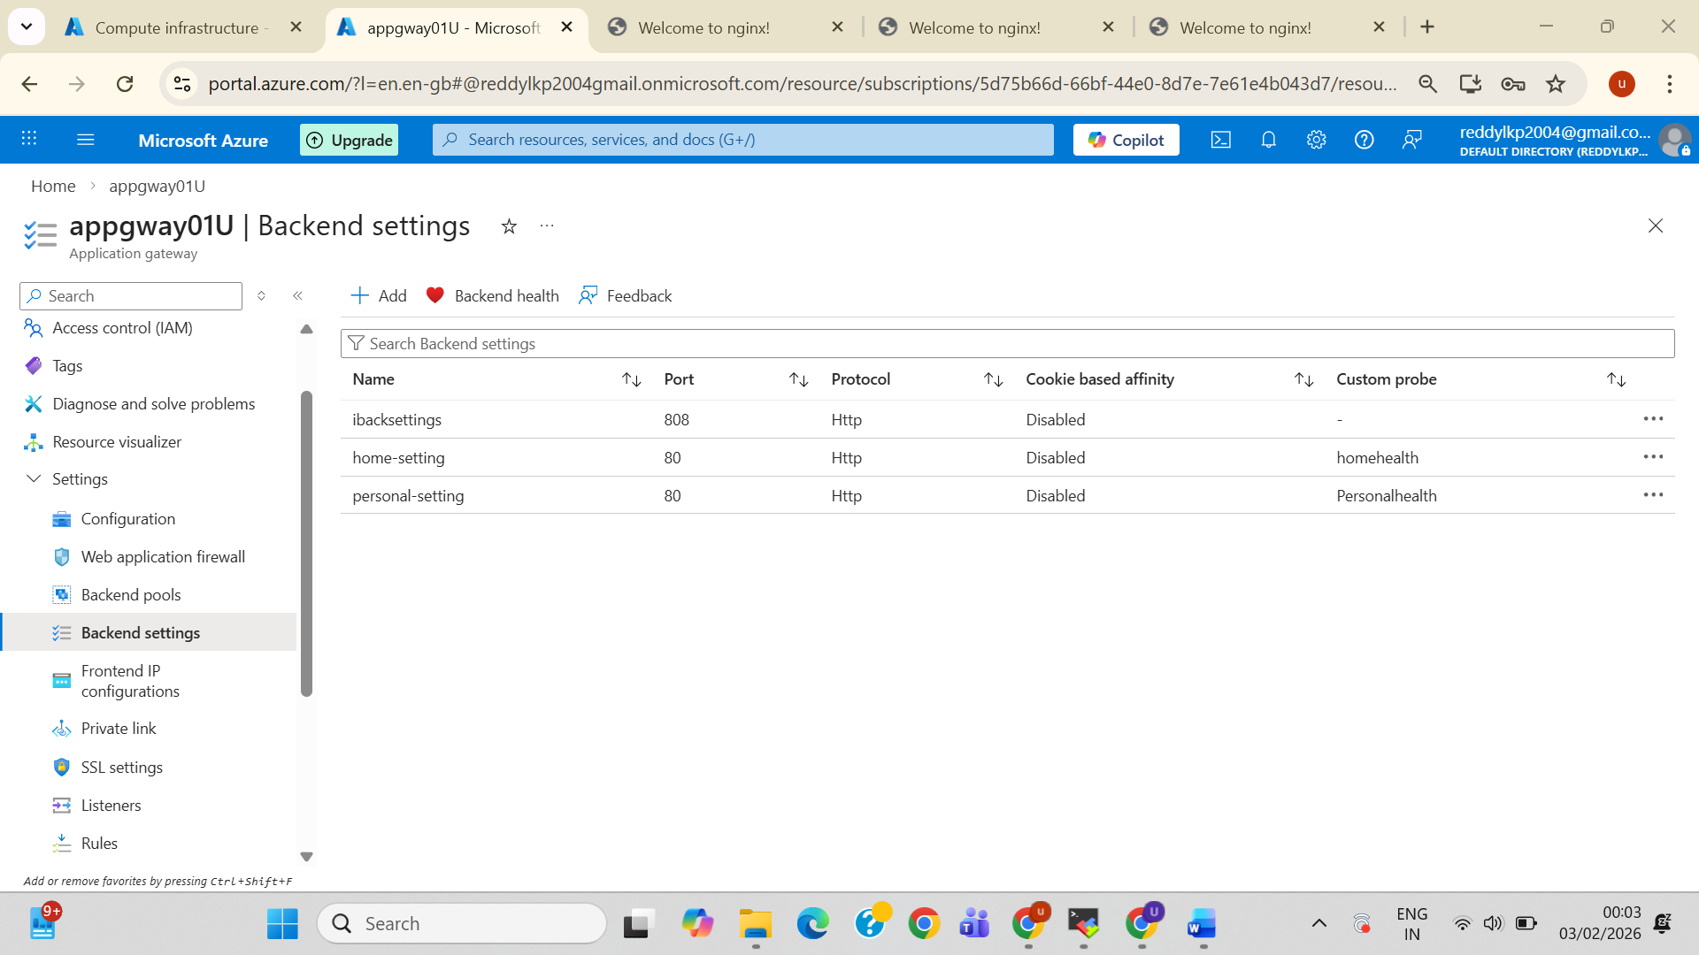

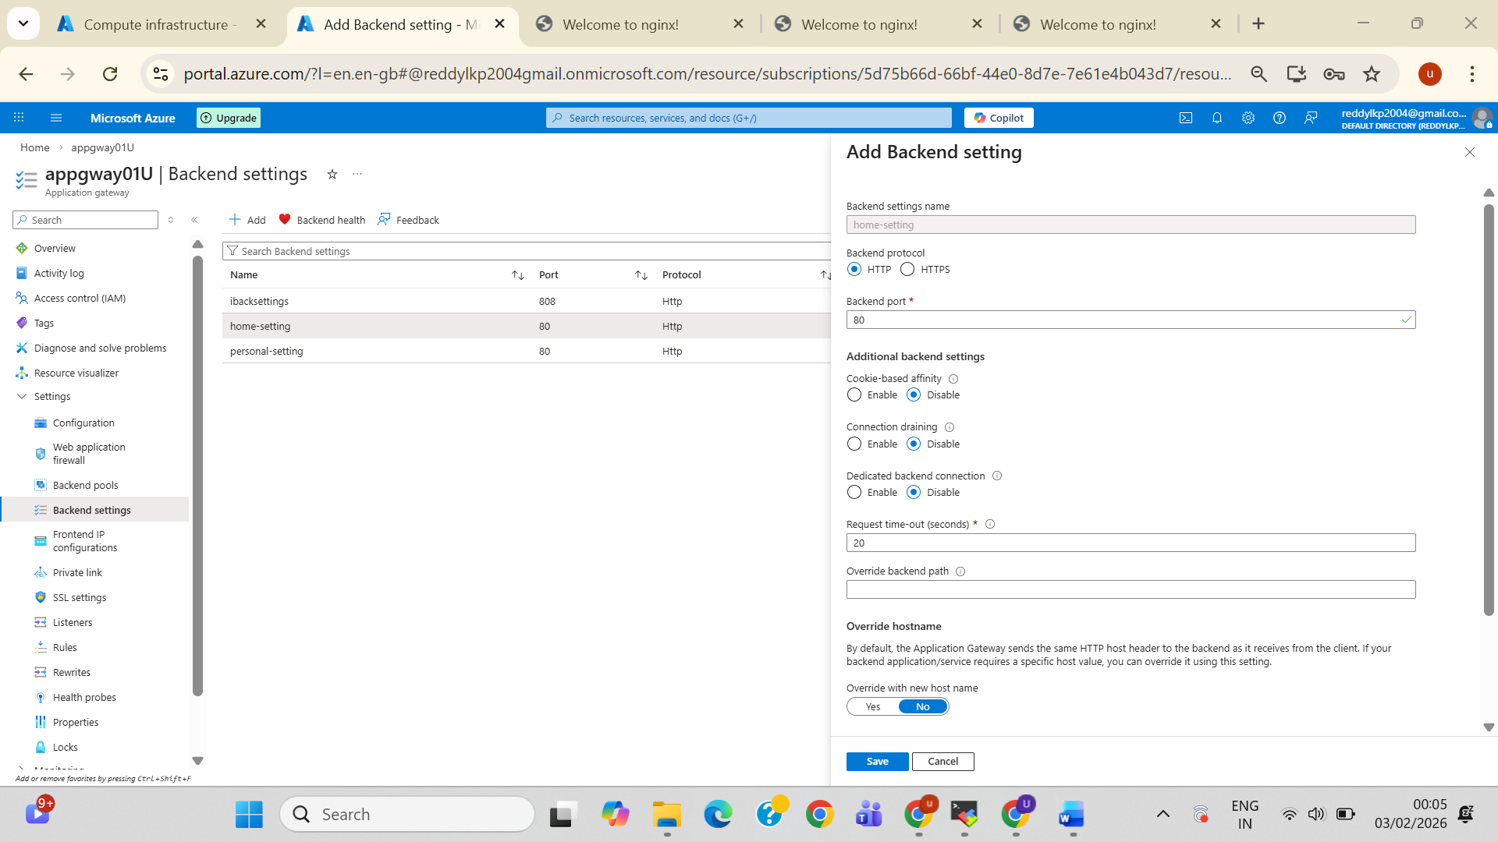

* **Listerners**

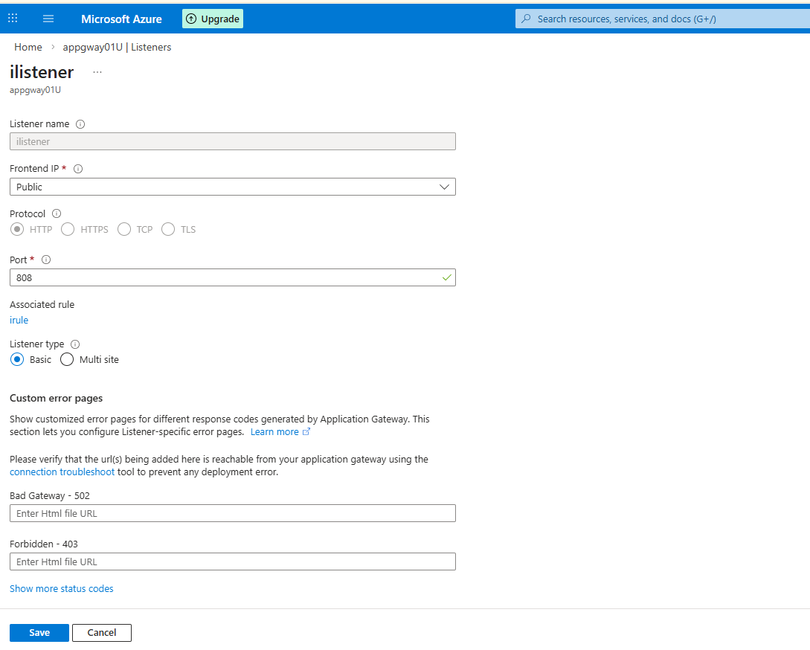

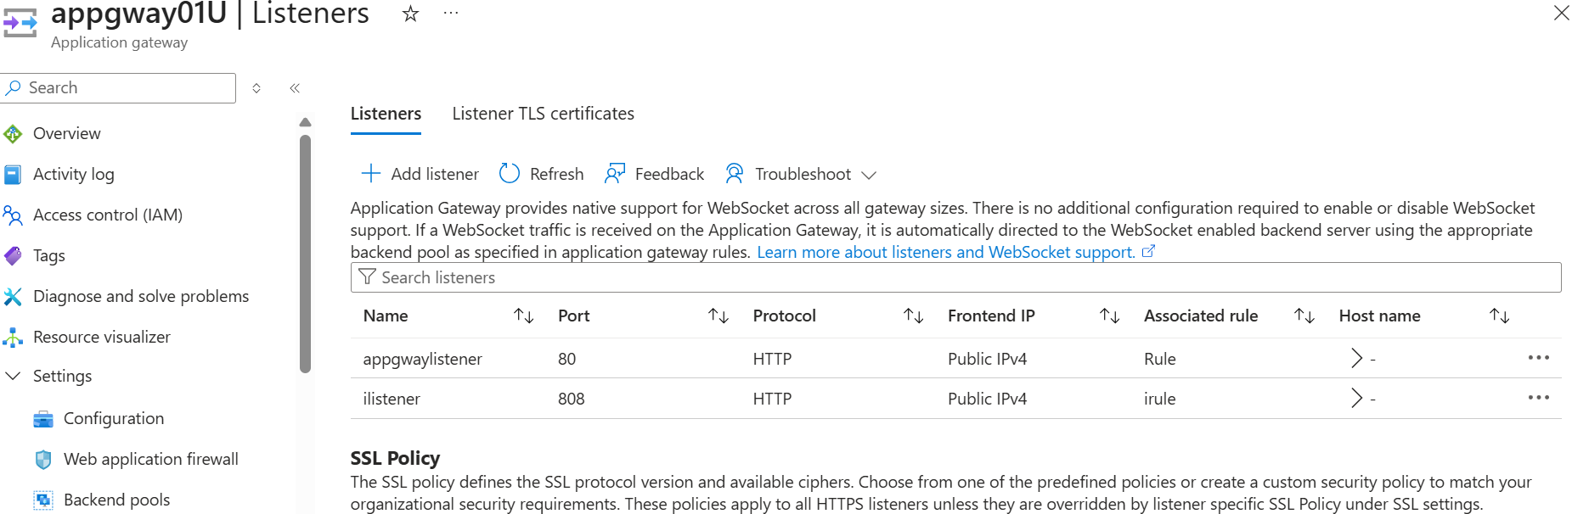

* **Health Probe**

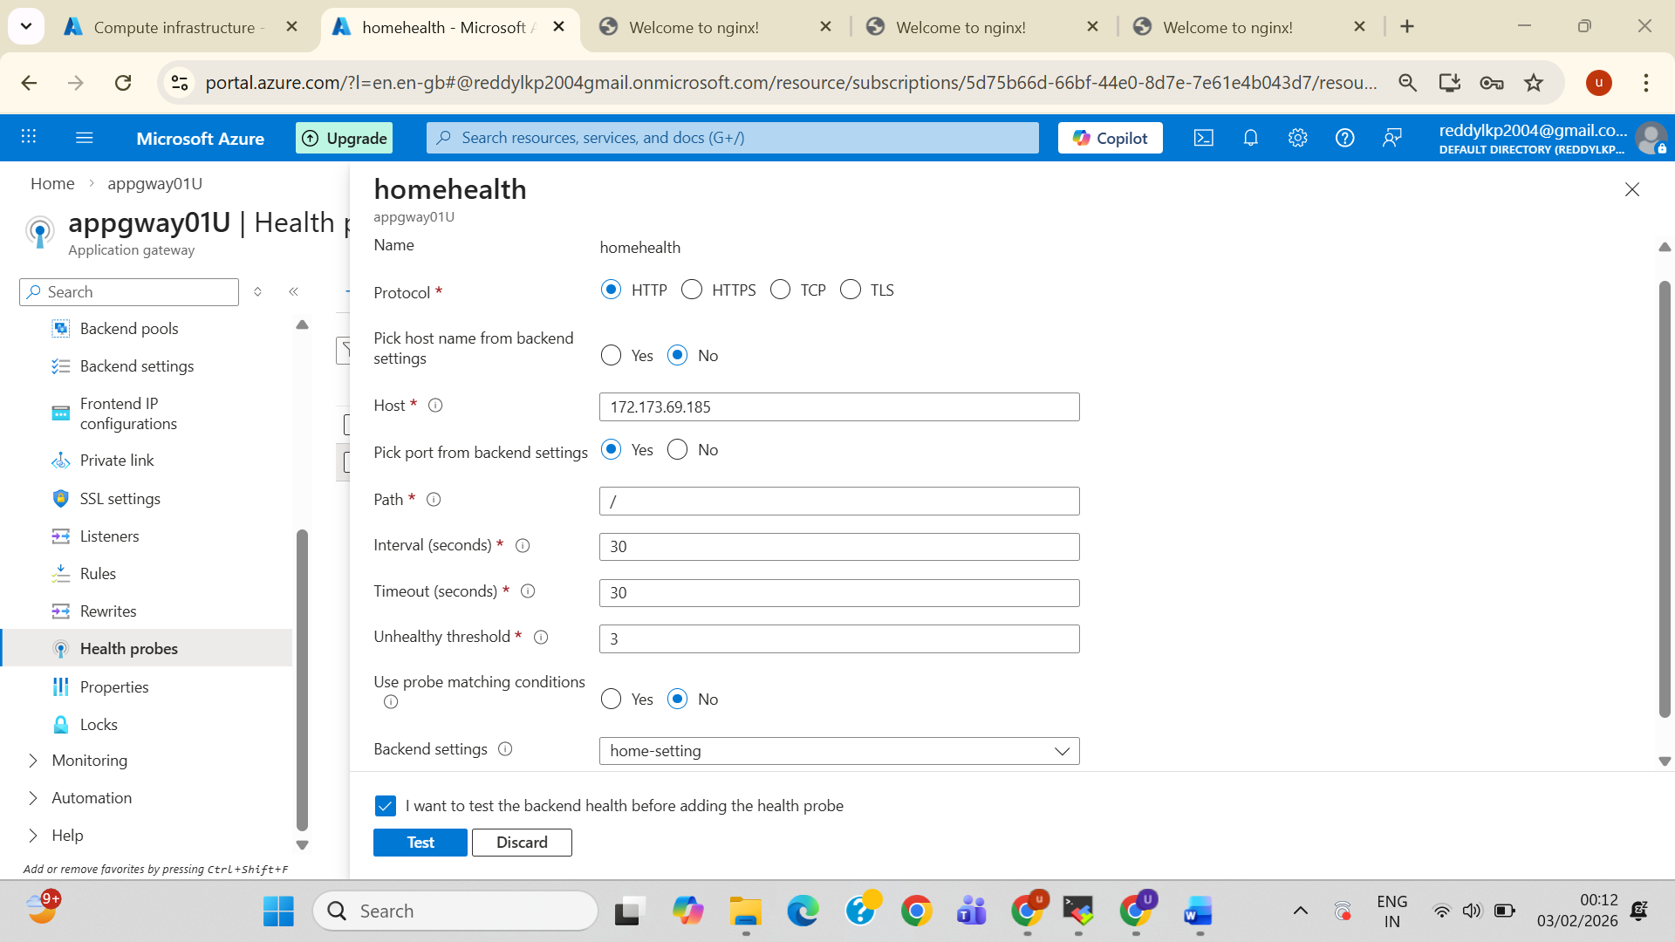

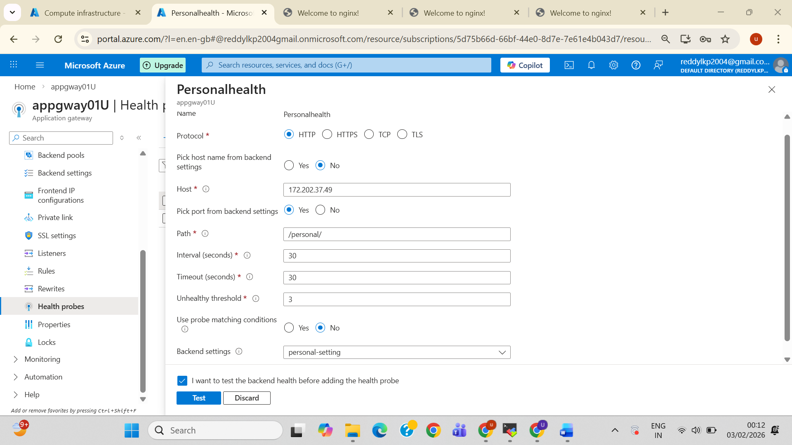

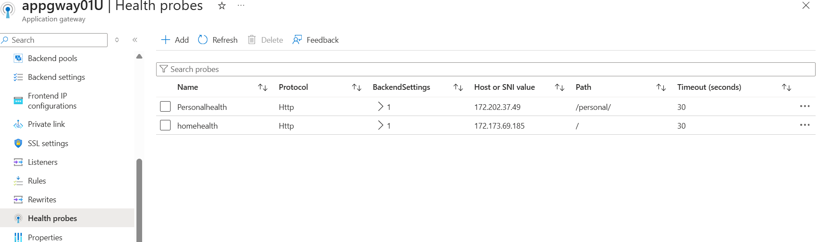

* **Know Configure Path Base Routing**
* **Rules**

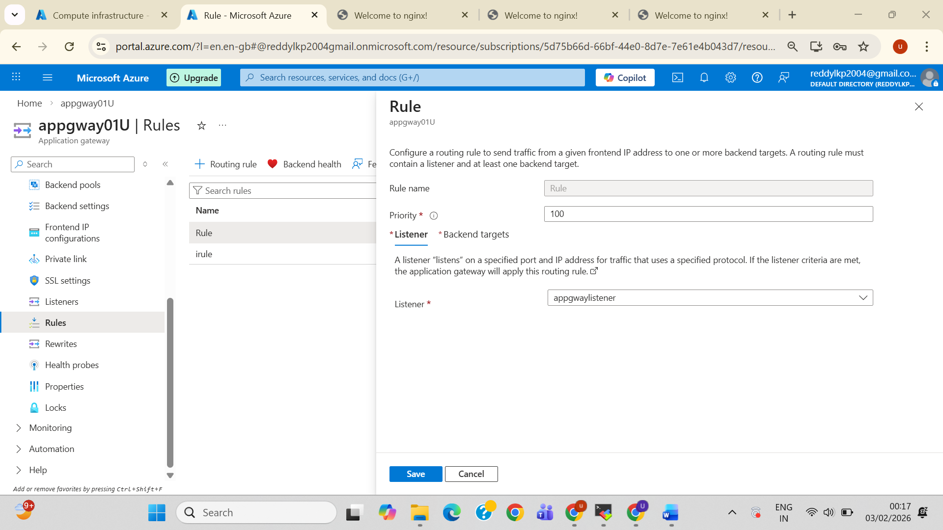

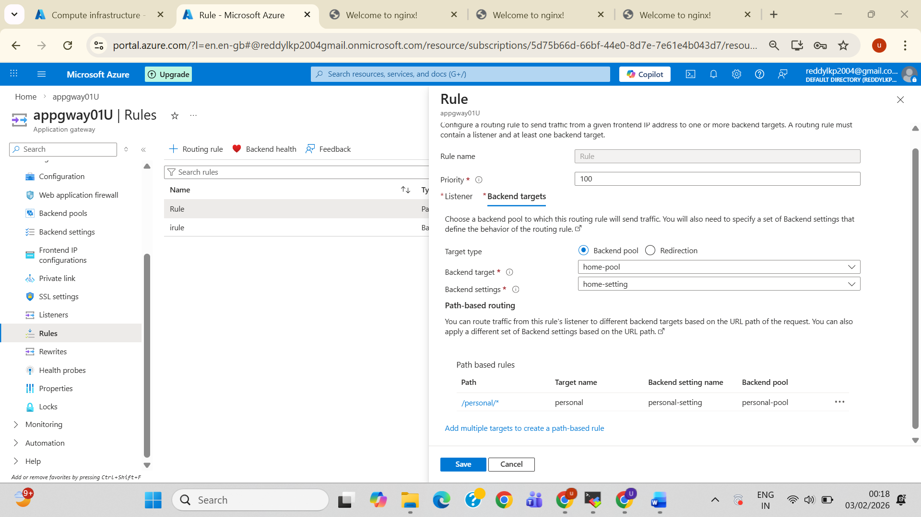

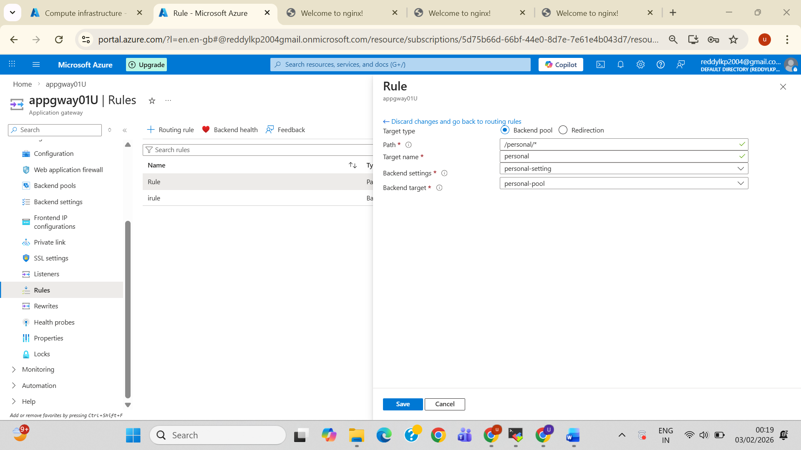

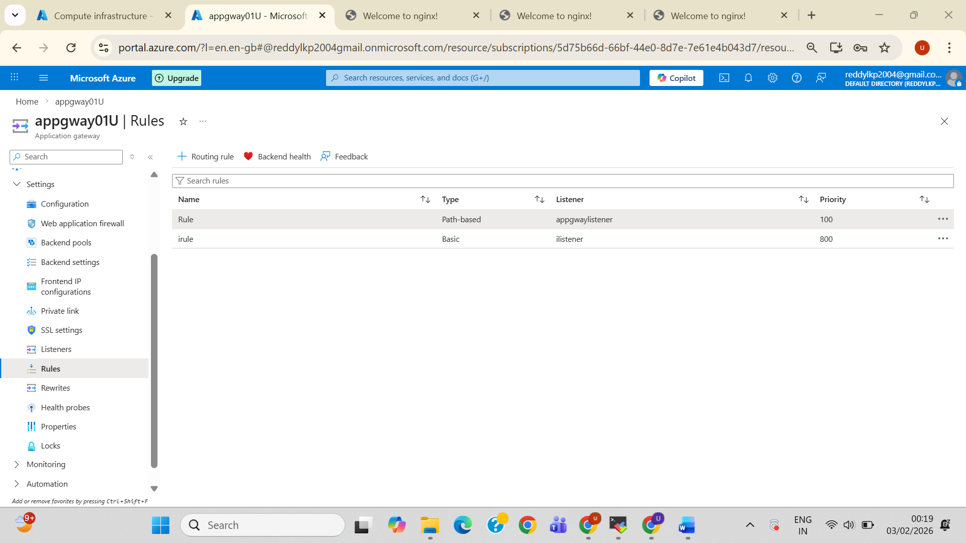

* Frontend IP configurations(Copy Pip) and Browse

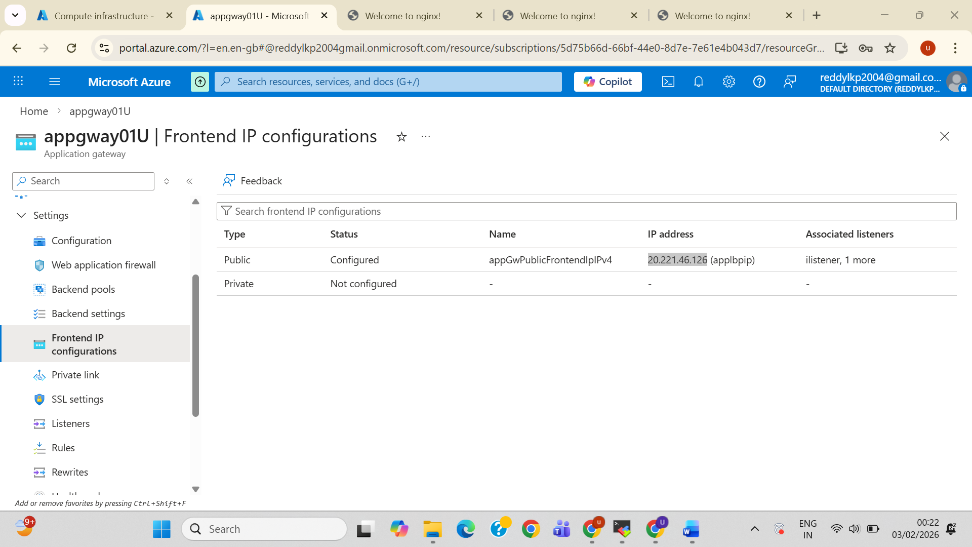

* **Result browse with this Appication Gatway-Pip 20.221.46.126 (applbpip)**
* **20.221.46.126/**

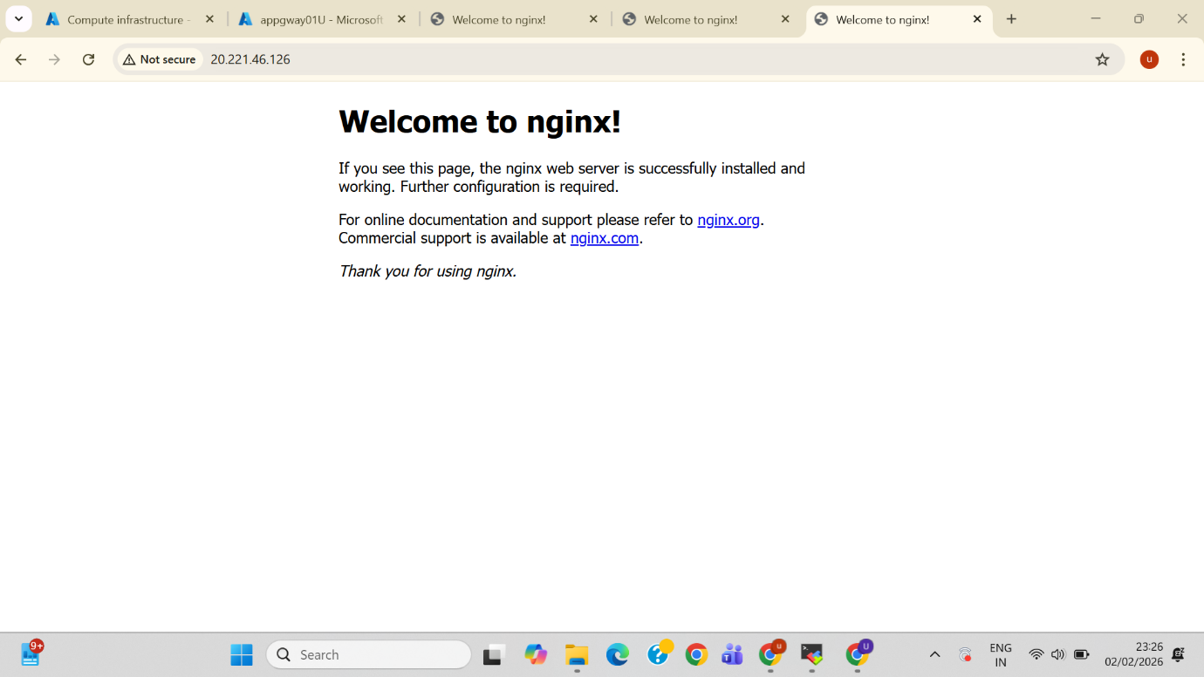

* **20.221.46.126/personal/**

